You are a Sustainability professional building a website and community of similar professionals looking to connect with each other, spread ideas, and find work.

You want to make a website called Chronocept Revolutions. You already have a YouTube channel which is also called Chronocept revolutions. The idea is that the website and the YouTube channel will together talk about ideas around the world which can be used in a specific context to make things better in that country and help build a sustainable society. Some of the goals of the website are:

Build a community of people wanting to build a sustainable future. (immediate)
Make economic, financial, and sustainable ideas accessible by spreading them for free with certificates that they can use in topic specific courses to get jobs by having the certificates on Linkedin (immediate)
Draw on the community to do actual real-world project work for government, private clients, or NGOs (long-term)

To reach these goals, the aim is to start creating content and blog posts for spreading ideas. Seperately, start working on courses to provide education on specific upskilling skills like AI, Solar, BESS, Renewable energy financing and other sustainability topics.

We need to keep in mind that content creation is more immediate while the courses are a more long-term goal once we get enough traction.

Finally, Here are the design needs for the website.

Front-end

This is my portfolio website. I want to use the same color themes, fonts etc to keep them consistent and also because I want to incorporate the portfolio into the website

The first page should have the look and feel like this:
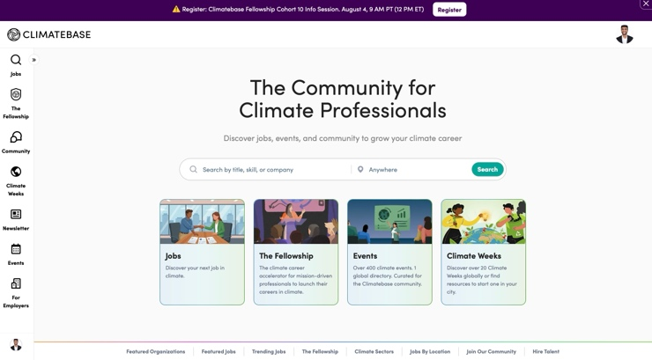

This is a climate based job board which does the same thing but there are a few differences I want to highlight.

- Our mission will always be to spread knowledge for free to all as education is a basic human right (Unlike Climatebase which takes money for its cohorts)

- Anyone can submit blog posts for us that we will consider making videos on (we will provide a specific format for it)

- Instead of posting jobs, we will collect resume’s and keep them on file. If organizations reach out or if we see opportunities that would be a good fit, we will take the people on board as independent consultants rather than offering full-time roles

Unlike the Climatebase website, I don’t want any controls on the left. Instead I want the navigation bar on the top which remains there even if people slide down on the page so it should be like a fixed freeze pane).

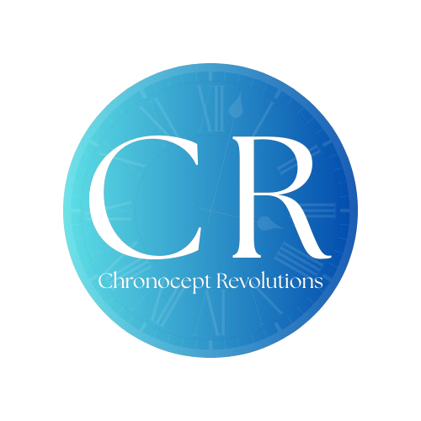
This is the Chronocept Revolutions logo which should be on the website. While keeping the rest of the colors the same, you can switch the green color in my portfolio and here to this blue. So, it will be baige and blue rather than green and baige.

The top navigation bar should have ‘Home’; ‘Content’; ‘Submit a CR’; ‘Learning’ and ‘Opportunities’ and ‘Profile’.

In the Home page, I want to start with a short section explaining what Chronocept Revolution is, what the mission and vision is, and why we are delivering content through videos. We want the website to be a on-stop shop for people looking to build a better future whether it is learning about specific economic, sustainability, or finance concepts that can help their country or community; whether it is learning to upskill so they can become masters in their field and be productive members of the society, or whether they are looking for job opportunities or simply to make friends with like-minded people through the community

I want to have a global map similar to the one in my portfolio which has clickable countries. When you hover over the country, it says its name and if they click it, it takes them to the page that has content we created talking about that country and the option to see general content at the bottom of the page. It should show a maximum of 10 videos with its associated blogs and an option to move between pages at the bottom below which it has the option to see general global content (content that is relevant to all countries). The general global content should come in a clickable, slideable, panel showcasing the newest global content we created.

Even above the map on the home page, there should be an option to click and view the videos by newest, global, and most viewed
Below the map then on the home page, there should be an option to click on ‘Subscribe’ to get the most recent updates which allows the user to sign up using their email and upload their CV. In the beginning we will only collect information and keep the effort for the user at a minimum since we are only trying to get traction. Eventually we will expand it to opportunities and setting up a full account and learning etc.

We will then have the option to ‘Submit a CR’ which will take them to the ‘Submit a CR’ page. Essentially, the idea is that they can write blogs using our downloadable template and submit it to us on specific topics that they are experts of or have done research about. We will then check their sources, make a video on that topic and provide them credit in the blog and the video which they can ‘sell’ on their resume. This will be more hand-on than just their comments on a video for example, and both the video and blog will have a photo of them with specifications we provide them so they can share it with their friends, family, and potential employers.

The aim will be to keep political views aside and speak subjectively on whether a country/economy is doing something right or wrong (the issue); compare it to what other countries are doing and why the solution there is working (How others do it); and what the solution is and how it should be applied (the solution). Every blog or video must be structured the same way to speak about the complex ideas in the most coherent way.

Accordingly, in the Submit a CR page, we will have a disclaimer on what we expect, what we will do with what they submit, and how from submitting it, they are letting go of any financial etc gains from the blog as it will become CR’s property once a decision is made and accepted by them. Basically the process most be explained here that they submit>we check and verify> we edit if needed> we send them the edited version for reference and they sign a contract online that allows us to use and publish their blog> we make the video and publish. Each video will have the blog which will act as the ‘research’ behind the video which we will post so the blogs are not blogs by themselves but more a verification of what is in the video.

Then, in the Content section, it will essentially show the newest content and the most viewed content similar to a YouTube channel page. If they click on the content, it shows the video along with the blog below it. With a ‘suggestion’ panel below showing related-videos selected based on the tags of the video they are watching. The other three sections, Learning, Opportunities, and Profile are not needed straight away as they are part of the medium and long term but the options should remain in the backend when we decide to go live.
In the Home page, finally, we want to show the mission vision etc that you can make up based on what I have said. The

Backend

Connect the YouTube channel to the website
Ensure that the views on the website increase the views on the channel (as that is how we will make money)
Ensure the emails, names, countries, and CVs of people who signed up are stored
Ensure that there is a backend from where we can send auto-updates to people who sign up
Make sure that the long-term goal sections remain in the backend so I can push for updates later after working on those pages
Ensure it can be hosted on a secure server (I am willing to pay but I have no idea how to develop websites so you will need to provide the specific steps I need to do to get this working)
Ensure that I can make changes to the website easily using Word Press or something similar in addition to Claude code so I can make changes myself as needed but also ask for your help if needed.

